Wednesday, October 5, 2022
Eighteenth Sunday after Pentecost, 18C

Pastor Kim Swenson

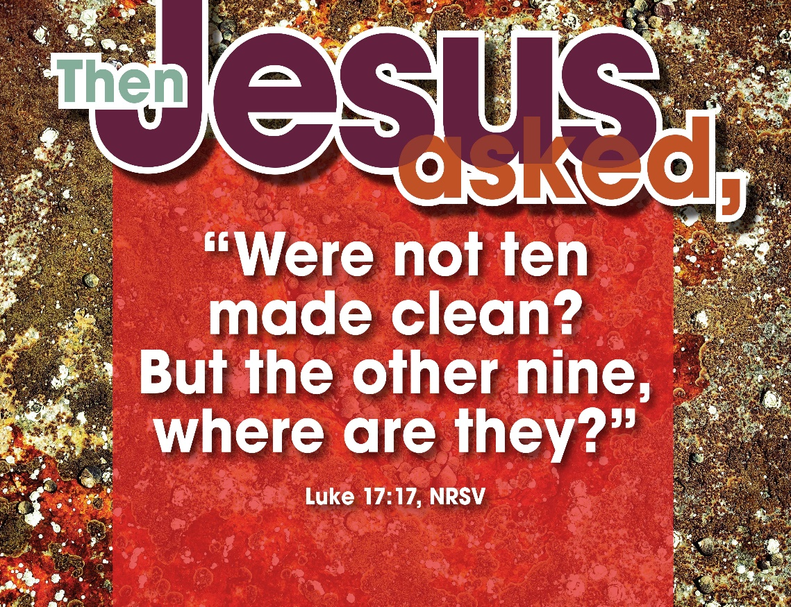

The Holy Spirit calls us together as the people of God. GATHERING

Prelude

Welcome
The congregation is invited to say the bold words.

Opening Hymn “Come, Thou Fount of Every Blessing” Cranberry #807

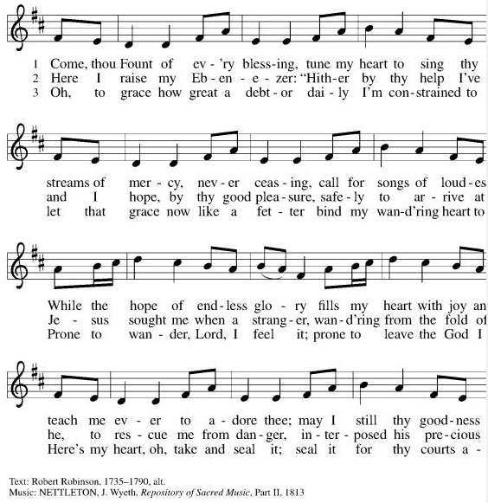
Call to Worship

Blessed be the holy Trinity, ☩ one God,
who is eager to forgive
and who loves us beyond our days. Amen.

We have gathered in this place to worship,
Because Jesus invites us to come!
We come as we are,
the young and the old with our faith and our doubts,
with our successes and our failures,
Because Jesus invites us to come!

Come Let Us Eat vs 3 Cranberry 491
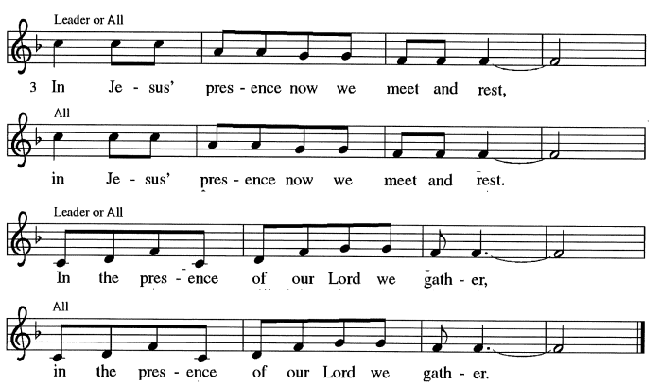

Prayer of the Day

The grace of our Lord Jesus Christ,
the love of God from which nothing can separate us,
and the life-giving Holy Spirit be with you all.
And also with you.

Let us pray, Almighty and most merciful God, your bountiful goodness fills all creation. Keep us safe from all that may hurt us, that, whole and well in body and spirit, we may with grateful hearts accomplish all that you would have us do, through Jesus Christ, our Savior and Lord.
Amen.

God speaks to us in scripture reading, preaching, and song. WORD

Scripture Reading: 2 Kings 5:1-3, 7-15c

¹Naaman, commander of the army of the king of Aram, was a great man and in high favor with his master, because by him the Lord had given victory to Aram. The man, though a mighty warrior, suffered from leprosy. ²Now the Arameans on one of their raids had taken a young girl captive from the land of Israel, and she served Naaman’s wife. ³She said to her mistress, “If only my lord were with the prophet who is in Samaria! He would cure him of his leprosy.” ⁷When the king of Israel read the letter, he tore his clothes and said, “Am I God, to give death or life, that this man sends word to me to cure a man of his leprosy? Just look and see how he is trying to pick a quarrel with me.” ⁸But when Elisha the man of God heard that the king of Israel had torn his clothes, he sent a message to the king, “Why have you torn your clothes? Let him come to me, that he may learn that there is a prophet in Israel.” ⁹So Naaman came with his horses and chariots, and halted at the entrance of Elisha’s house. ¹⁰Elisha sent a messenger to him, saying, “Go, wash in the Jordan seven times, and your flesh shall be restored and you shall be clean.” ¹¹But Naaman became angry and went away, saying, “I thought that for me he would surely come out, and stand and call on the name of the Lord his God, and would wave his hand over the spot, and cure the leprosy! ¹²Are not Abana and Pharpar, the rivers of Damascus, better than all the waters of Israel? Could I not wash in them, and be clean?” He turned and went away in a rage. ¹³But his servants approached and said to him, “Father, if the prophet had commanded you to do something difficult, would you not have done it? How much more, when all he said to you was, ‘Wash, and be clean’?” ¹⁴So he went down and immersed himself seven times in the Jordan, according to the word of the man of God; his flesh was restored like the flesh of a young boy, and he was clean.

^{15a-c}Then he returned to the man of God, he and all his company; he came and stood before him and said, “Now I know that there is no God in all the earth except in Israel.”

Word of God, Word of Life. Thanks be to God.

Psalm 111
¹Hallelujah! I will give thanks to the Lord with my whole heart,
in the assembly of the upright, in the congregation.
²Great are your works, O Lord,
pondered by all who delight in them.
³Majesty and splendor mark your deeds,
and your righteousness endures forever.
⁴You cause your wonders to be remembered;
you are gracious and full of compassion.
⁵You give food to those who fear you,
remembering forever your covenant.
⁶You have shown your people the power of your works
in giving them the lands of the nations.
⁷The works of your hands are faithfulness and justice;
all of your precepts are sure.
⁸They stand fast forever and ever,
because they are done in truth and equity.
⁹You sent redemption to your people and commanded your covenant forever;
holy and awesome is your name.
¹⁰The fear of the Lord is the beginning of wisdom;
all who practice this have a good understanding. God’s praise endures forever.

Gospel Acclamation
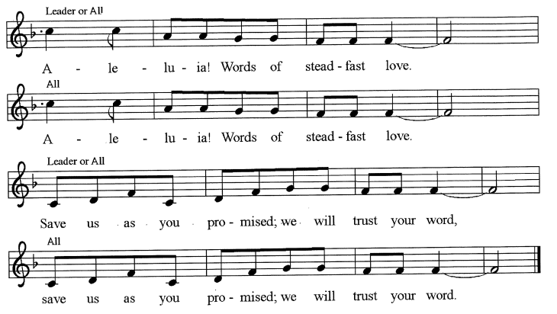

Gospel: Luke 17:11-19

The Holy Gospel according to St Luke. Glory to you, O Lord.

¹¹On the way to Jerusalem Jesus was going through the region between Samaria and Galilee. ¹²As he entered a village, ten lepers approached him. Keeping their distance, ¹³they called out, saying, “Jesus, Master, have mercy on us!” ¹⁴When he saw them, he said to them, “Go and show yourselves to the priests.” And as they went, they were made clean. ¹⁵Then one of them, when he saw that he was healed, turned back, praising God with a loud voice. ¹⁶He prostrated himself at Jesus’ feet and thanked him. And he was a Samaritan. ¹⁷Then Jesus asked, “Were not ten made clean? But the other nine, where are they? ¹⁸Was none of them found to return and give praise to God except this foreigner?” ¹⁹Then he said to him, “Get up and go on your way; your faith has made you well.”

The Gospel of the Lord. Praise to you, O Christ.

Sermon

Hymn of the Day “Baptized in Water” Cranberry #456

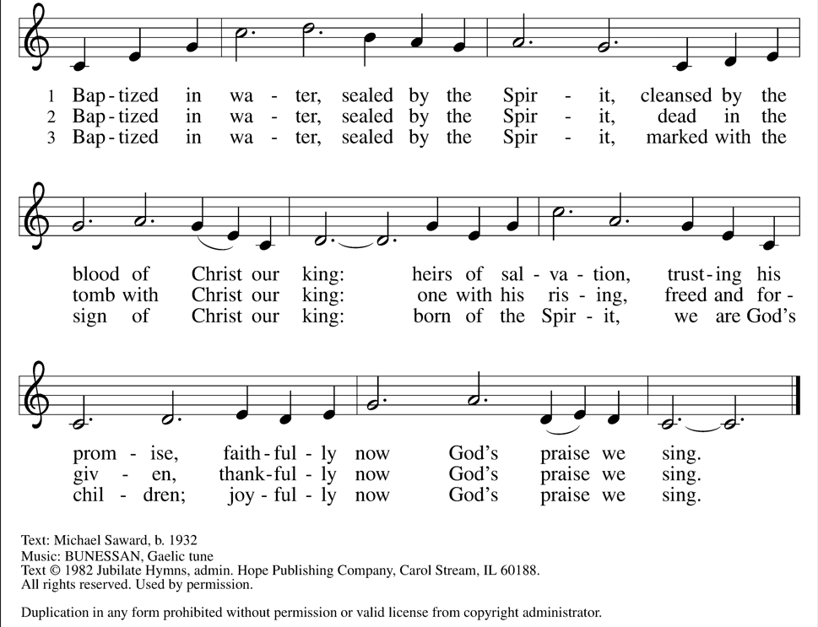

Apostles Creed

I believe in God, the Father almighty,
creator of heaven and earth.
I believe in Jesus Christ, God’s only Son, our Lord,
who was conceived by the Holy Spirit,
born of the virgin Mary,
suffered under Pontius Pilate,
was crucified, died, and was buried;
he descended to the dead.
On the third day he rose again;
he ascended into heaven,
he is seated at the right hand of the Father,
and he will come to judge the living and the dead.
I believe in the Holy Spirit,
the holy catholic church,
the communion of saints,
the forgiveness of sins,
the resurrection of the body,
and the life everlasting. Amen.

Prayers of the People
As scattered grains of wheat are gathered together into one bread, so let us gather our prayers for the church, those in need, and all of God’s good creation.

A brief silence.
Gracious God, we give you thanks for bishops, pastors, and deacons. Inspire leaders of the church to proclaim your mighty deeds, that your saving faith may be known to all. Hear us, O God. Your mercy is great.

Majestic God, we give you thanks for land and water, seedtime and harvest. Break down boundaries we construct between ourselves and the rest of your creation. Bring renewal and restoration to places affected by pollution and deforestation. Hear us, O God. Your mercy is great.

Mighty God, we give you thanks for those in our community, nation, and world who work for justice and peace. Guide those who govern to act on behalf of those marginalized by race, ethnicity, or religion. Hear us, O God. Your mercy is great.

Merciful God, we give you thanks that you hear the cries of those in need. Restore to community those who are stigmatized by illness, feel rejected, or who live in isolation. Send healing to all who suffer. Hear us, O God. Your mercy is great.

Faithful God, we give you thanks for the healing ministries of this congregation. Equip those who visit, care, and pray for the sick especially those on the Bethel prayer list. Give insight to doctors, nurses, home health aides, and all practitioners of medical arts. Hear us, O God. Your mercy is great.

For what else do the people of God pray?
Silent and spoken prayers are invited

Eternal God, we give you thanks for your faithful people who have gone before us to your glory. Renew our trust in your eternal promises of mercy, redemption, and new life. Hear us, O God. Your mercy is great.

With grateful hearts we commend our spoken and silent prayers to you, O God; through Jesus Christ, our Lord.
Amen.

Peace

The peace of Christ be with you always. And also with you.
Please share a sign of the Lord’s peace with those around you.

God feeds us with the presence of Jesus Christ. MEAL

Offering Prayer

Before us is a world in great need, waiting in hope.
We are a people holding treasure meant to be given away:
the good news of Christ; resources of time, talents, and money.
All we have is a gift from God;
therefore let us offer our lives to the Lord.

Let us pray, Gracious God,
in your great love you richly provide for our needs.
Make of these gifts a banquet of blessing,
and make us ready to share with all in need;
through Jesus Christ, who sets a table for all. Amen.

Come Let Us Eat vss 1-2 Cranberry 491
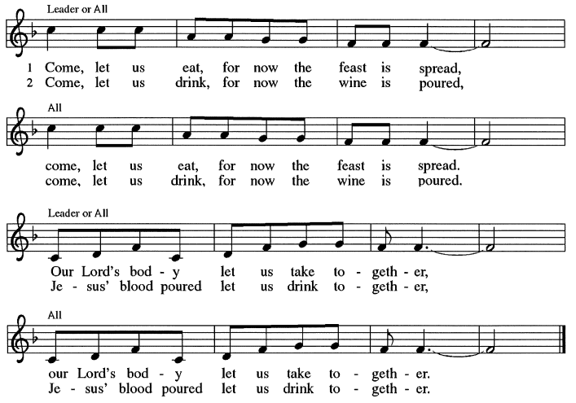

Great Thanksgiving

The Lord be with you.
And also with you.
Lift up your hearts.
We lift them to the Lord.
Let us give thanks to the Lord our God.
It is right to give our thanks and praise.

We give you thanks, Lord God,
for the blessing of your law
and the challenge of your prophets.

You have shown favor to your lowly servants
and remembered your promise to our ancestors.
You have been faithful to your covenant
and rescued us from the hands of our enemies.
You have revealed your saving purpose to all,
a light to the nations for the glory of your people.

We give you thanks, Lord God,
for the coming of Jesus Christ
and the proclamation of his kingdom.

Jesus was anointed to bring good news to people who are poor,
proclaim release to people who are captive,
restore the sight of those who are blind,
grant freedom to those who are oppressed,
and announce the year of your favor.
Let these words be fulfilled today.

In the night in which he was betrayed,
our Lord Jesus took bread, and gave thanks;
broke it, and gave it to his disciples, saying:
Take and eat; this is my body, given for you.
Do this for the remembrance of me.

Again, after supper, he took the cup, gave thanks,
and gave it for all to drink, saying:
This cup is the new covenant in my blood,
shed for you and for all people for the forgiveness of sin.
Do this for the remembrance of me.

We give you thanks, Lord God,
For the gift of the Holy Spirit
And the calling of the church.

Pour out your Spirit upon all flesh.
Keep us ever faithful, devoting ourselves
to the apostles’ teaching and fellowship,
the breaking of bread and prayers,
until Christ returns in glory to reign. Amen.

The Lord’s Prayer

Lord, remember us in your kingdom and teach us to pray.

Our Father, who art in heaven,
hallowed be thy name,
thy kingdom come,
thy will be done,
on earth as it is in heaven.
Give us this day our daily bread;
and forgive us our trespasses,
as we forgive those
who trespass against us;
and lead us not into temptation,
but deliver us from evil.
For thine is the kingdom,
and the power, and the glory,
forever and ever. Amen.

God blesses us and sends us in mission to the world. SENDING

Announcements

Come Let Us Eat vs 4 Cranberry 491
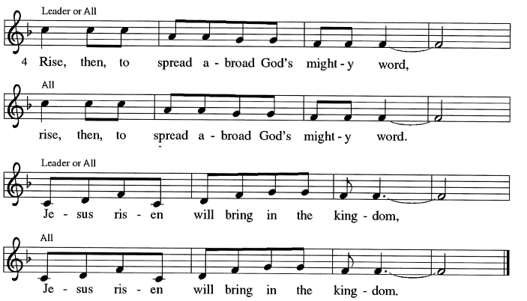

Benediction

God, who gives life to all things
and frees us from despair,
bless you with truth and peace.
And may the holy Trinity, ☩ one God,
guide you always in faith, hope, and love. Amen.

Hymn “O Light Whose Splendor Thrills” Cranberry #563

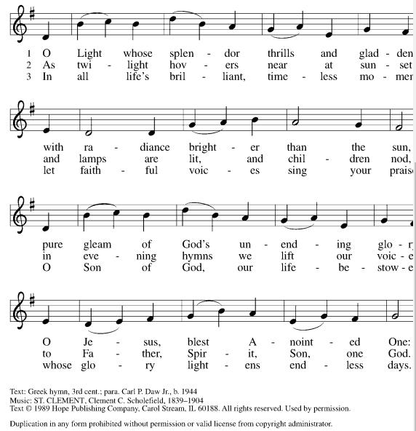

Dismissal

Go in peace, with Christ beside you.
Thanks be to God.

Bethel Weekly

Funeral for Gayle Anderson will be Friday October 7th at 11 am with meal following. Visitation will be from 9-11am.

Pastor Kim will be gone Saturday and Sunday to Iowa for her 25th college reunion.

NEW Shelter Meal will be Sunday, October 9th at 11am. A sign-up sheet is in the hallway. 6 dozen bars/cookies are needed.

New Members will be meeting with Pastor Kim on October 16th and installed on October 30th.

Pastor’s Theological Conference will be in Door County October 17th-19th.

Special Congregational Meeting will be Sunday, October 23rd to vote on the first draft of the constitution and expense to make the back door completely handicapped accessible.
Trunk or Treat will be October 31st from 4-5:30pm. Decorate your car and join the crew to greet our neighbors!

All Saints Sunday sign-up for those newly baptized and new Saints in heaven in the past year is in the hallway on the sign-up board. Please add names of your friends and family.

Worship Assistants
Assisting Minister: Doug Scholes
Altar Guild: Peggy Hansen
Ushers: Dick Schoen
Doug Hansen
Video Tech: Yvonne Pamperin

Copyright and Streaming Licenses:
Augsburg Fortress Liturgies License #22041
CCLI License #2623795
One License #734715-A
Eucharist Prayer edited from Connections:
Worship Companion Year C, Volume 2.

This Week at Bethel Lutheran Church
Wednesday, October 5
6:30 - Worship
7:15 - Choir
Thursday, October 6
10:00 - Peace
1:00 - Faith
Friday, October 7
11:00 - Gayle Anderson
Funeral
Sunday, October 9
No Worship
Monday, October 10
6:30 - Council Meeting
Wednesday, October 12
10:00 - Mission Sewing
7:00 - Bethel Choir
Thursday, October 13
9:30 – Library
Saturday, October 15
9-4:30 Racial Equity Training
Sunday, October 16
9:00 - Worship
10:00 - Tone Chime/New Member/Buildings & Grounds

